Image to Text (Extract Text From Image)
May 2022 (no.7)  Question 1  Assume that you are a software engineer in Solve IT Sdn. Bhd, a software development company in Kuala Lumpur. Your company has won a project contract from Majlis Bandaraya Melaka Bersejarah (MBMB) that required your team to develop an e-commerce mobile application. This e-commerce mobile application is named as The Pasar Online (PsrO) and it is expected to help the registered market retailer to be able to increase their sales and to enable the customer to buy wet food from the wet market online.  The application will provide online purchase for wet food such as fish, meat and vegetable from Pasar Besar Melaka Sentral to customers in Melaka Tengah district. The PsrO is expected to provide online wet food ordering services to serve various parties such as registered market retailer, the runner and the customer.  MBMB has clearly mentioned that they will only pay for the application but the application will be used mainly by the registered market retailer in Pasar Besar Melaka Sentral to advertise and sell the wet foods, the customer to buy and the runner to deliver the wet foods. MBMB has provided a group of main users that may help with the requirements, but most of them do not have any background or knowledge in dealing with electronic system. In another hand, MBMB has also mentioned that the e-commerce mobile-based application idea is inspired by the current applications such as FoodPanda and Grab.  The Psro is also expected to have special features to make online payment, locating and tracking current status of the ordered wet foods. Additionally, MBMB hopes the application to be simple, easy to use and all the transactions to be safe and they will be looking forward to seeing the initial version of application earlier.  Your team is given six (6) months to complete the application and to speed up the development process, your company has recently hired two part-time staffs. | a) Recommend ONE (1) software process model to develop the Psro e-commerce mobile application as mentioned above and justify your recommendation with FOUR (4) reasons based on the above scenario. (1+8 marks)  Incremental Model  - Faster Delivery: Incremental development enables quicker delivery of software, ensuring PsrO reaches MBMB sooner.  - Flexibility: Version-based approach allows for easy adjustments to cater to the diverse, non-technical user base.  - Risk Management: Developing in increments helps manage risks, especially important for users unfamiliar with electronic systems.  - Adaptability to Short Staff: With limited staff, focusing on one module at a time makes the project manageable by building the application incrementally  b) Identify and describe any THREE (3) important code of ethics that you need to follow as a software engineer in the software development company. (6 marks)  - Act in the public interest: prioritize the safety, privacy and well-being of the PsrO users  - Prioritize client and employer interests: ensure that PsrO meets the needs of the market retailer, runner and the customer  - Ensure product quality: make sure that PsrO is high quality, meets all specified requirements and functioning reliable  c) Suggest and explain THREE (3) software quality attributes for the PsrO e-commerce mobile application as mentioned above. Justify your suggestions. (6 marks)  - Usable: Making the app user-friendly to encourage adoption among users who may not be familiar with electronic systems.  - Reliable: Ensuring the app works consistently, especially for transactions and deliveries, to build trust with users.  - Secure: Implementing strong security measures to safeguard online payments and personal data.  d) As a software engineer, you would need to consider the factors that could motivate your project team members throughout the Psro e-commerce mobile application project. Identify and explain TWO (2) motivating factors for the software project as mentioned above based on the Maslow Motivation Model. (4 marks)  - Self-Actualization: Provide team members with challenging tasks and opportunities to contribute, fostering personal growth and a sense of achievement.  - Esteem Needs: Recognize and appreciate team members' efforts to boost confidence and maintain high performance.
Question 2  Dr. Aisyah has requested a management system for her clinic to assist all the aspects of management and operations of clinic. Currently, the management of the clinic is done manually. All records such as the patient records, medicine and sales are stored in files. In case where the patient is unsure whether they have previously received any treatment in the clinic or not, the admin staff will register the patient again.  Due to this practice, data retrieval has become complicated and this has leads to the data inconsistency and redundancy. On the other hand, for the clinic management purposes, the admin staff have to prepare daily sales reports on number of patients and the sales. Another tedious乏味 task is the medicine inventory.  As the current practice, the inventory for the medicine is also done manually. The medicine will be provided by the pharmacist to the outpatient based on doctor's prescription but this will be recorded in a small book manually. Every week, the admin staff have to spend time to check for the medicine in and out stock and place order to medicine supplier if the stock is low.  Dr. Aisyah is very hopeful that your company will provide the computerised system solution with useful functionalities for her employees.  The project will start on June 2022 and from the initial meeting, you and your team has drafted main tasks that will be executed in the project along with its duration for the project schedule. The main tasks are to collect requirements, analyse processes, analyse data, design processes, design data, design screens, design reports, coding, testing and deploy, which all these main tasks must be performed sequentially. Analyse processes will take 2 weeks and analyse data will take 3 weeks and both tasks can start immediately once the completion of collect requirements task that expected to take 2 weeks.  Once both the analyse tasks ended, the design processes, design data, design screens and design reports tasks will start one by one sequentially and all these design tasks are expected to take 2 weeks for each task. The coding tasks will take about 4 weeks and will start once the all the design tasks completed. The testing tasks will start once 75% of the coding task completed. And the testing task will take about 3 weeks and once it is completed the system will be deployed within a week time. All these tasks are expected to be completed within 5 months.[Total: 25 marks] | a) Identify and briefly explain TWO (2) techniques for discovering requirements for the above project. (4 marks)  - Interviews:  Conducting interviews with key stakeholders such as Dr. Aisyah, admin staff, doctors, and pharmacists will help gather detailed insights into their needs, challenges, and expectations. This technique will enable the team to collect information on specific requirements and pain points related to the current manual processes in the clinic.  - Observation:  Observing the clinic's day-to-day operations and workflow allows the team to identify inefficiencies and gaps in the manual system. By witnessing how patient registration, medicine stock management, and report generation are currently handled, the team can discover areas where automation could enhance the clinic’s operations.  b) Construct FOUR (4) functional requirements and TWO (2) non-functional requirements for the above project.  (6 marks)  Functional Requirements:  - The system must allow authorized staff to create, access, update, and retrieve patient records without duplication.  - The system must track medicine inventory, generate alerts when stock is low, and facilitate the ordering process from suppliers.  - The system must generate daily sales reports, including the number of patients served and total revenue generated.  - The system must link prescriptions to patient records and ensure that pharmacists can dispense medicines based on doctors’ prescriptions.  Non-Functional Requirements:  - Usability:  - The system must have a user-friendly interface that can be easily operated by staff with varying levels of technical expertise.  - Reliability:  - The system must ensure data accuracy and consistency, even in the case of system failures, with minimal risk of data corruption.  c) Prepare a Gantt Chart for the above project based on the information given.(10 marks)  d) Assume that you are planning to adopt a viewpoint-oriented analysis method for the requirements analysis process. Identify any FIVE (5) related viewpoints and construct a viewpoint hierarchy diagram to present your viewpoints for the above project. (5 marks)  interactor vp  - nurse  - doctor  indirect vp  - supplier  - finance manager  - manager  - chief executive officer (ceo)  domain vp  - UI standard
Question 3  Subsitika Institute has been operating since 1979 and started to use customised book inventory system since 1983 to manage the books in their library. One of their legacy systems is a text file storage server which stores large amount of the synopsis of books. The system has gone through a lot of modifications as the needs of their staffs changing from time to time. However, since 2001 the supplier of the system has closed down their business and stopped providing maintenance to the system. Your company have been contacted by Dato' S. Sashtika the CEO of Subsitika Institute to assist them in providing maintenance for their current book inventory system, however the CEO will be open to any of your suggestions.  After a short meeting with the IT manager in Subsitika Institute, you have started the preliminary study of the existing book inventory system. As a finding, you found out that there is a little documentation done and many important business rules that are included in the system are not documented or updated. The system is programmed by using COBOL and the software hardware specification of the system is outdated. There is no proper module design and therefore, the system has high coupling and low cohesion. Additionally, there is no testing and validation documentation provided. Subsitika Institute is requesting for a quotation for the inventory system's maintenance cost.[Total: 25 marks] | a)Based on your experience, discuss the FOUR (4) factors that could affect the maintenance cost of the above legacy system.  (8 marks)  b)Using the "Business Value" and "System Quality" categories for legacy system assessment, explain and justify the technique you should use to maintain the above legacy system. (3 marks)  c)Assume that the institute has decided to re-engineer the above legacy system, propose ONE (1) system organization/structuring design model. Explain and justify your answer. (6 marks)  d)Suggest FOUR (4) user interface design principles that must be applied in the proposed system. Justify your suggestions.  (8 marks)
Question 4  JooCha Fashion is a well-known fashion store that provides quality clothing for bridal, casual and modern fashion styles. The president of JooCha Fashion is planning to computerise a series of services such as clothes pre-order booking, clothing alteration services and collection, storing regular customers' information and et cetera. The regular customer member cards are planned to be converted into electronic identity (e-ID) to ease the purchase history record retrieval and discounting purposes. At the same time, the president has also complained about the rising cases of shoplifting in his store. He requested for a crime prevention features to overcome shoplifting in his shop. Roughly, replying to his request you have proposed additional feature by utilising the surveillance camera using security image processing techniques. This camera will be used to detect suspicious human behaviours in order to identify potential intruders or shoplifters. Additionally, each clothes in the shop will be clipped with bar code that will be disabled once the cloth is paid. In case the system identifies any suspicious human behaviours, it will alert the security guard by sending a warning message. And in case the shoplifter tries to bring unpaid items out of the shop, the alarm will be activated and the main door will be automatically locked. The president is interested with your idea and he is looking forward to the system development.  [Total: 25 marks] | a) Identify and explain THREE (3) sets of stimuli-responses for the crime prevention features of the system. (6 marks)  b) Propose and explain TWO (2) functional classification of Computer Assisted Software Engineering (CASE) tools with ONE (1) specific example of the tool for each classification that can be used by the company.(6 marks)  c) Assume that the company has decided to adopt Aspect Oriented Software Engineering (AOSE). Identify and construct a diagram to show FOUR (4) core concerns and ONE (1) cross cutting concerns for the system.(5 marks)  d) Explain TWO (2) testing techniques that can be used to test the system and include TWO (2) related samples of test cases for each testing technique.(8 marks)

202406
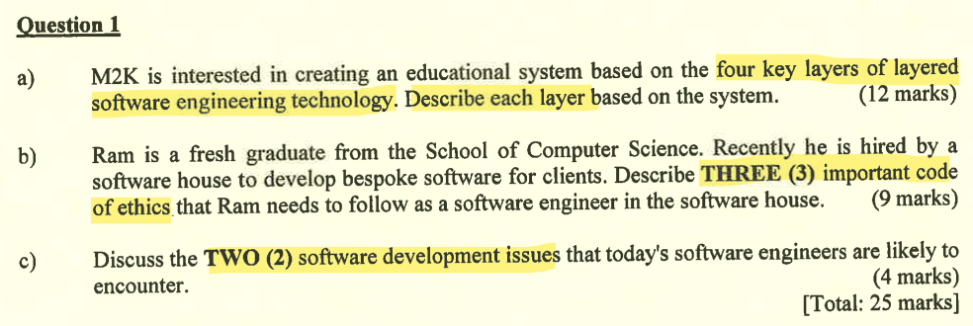 | key layers of software engineering technology 4  important code of ethics 3  software development issues 2  viewpoint-oriented analysis 2p2c  6VPs in hierarchy (identify  levels of Maslows 3  software process model (suggest+draw+explain phases  agile software development principles 6n  user interface designs principles 6mobileapp  non-func requirements  challenges using NL
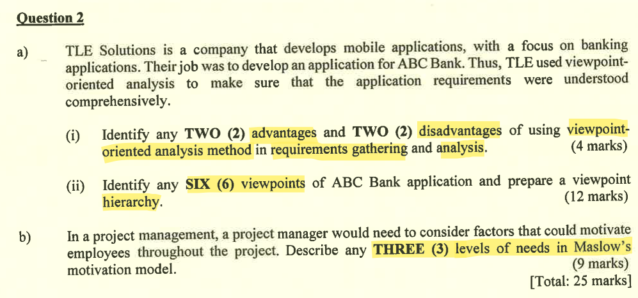
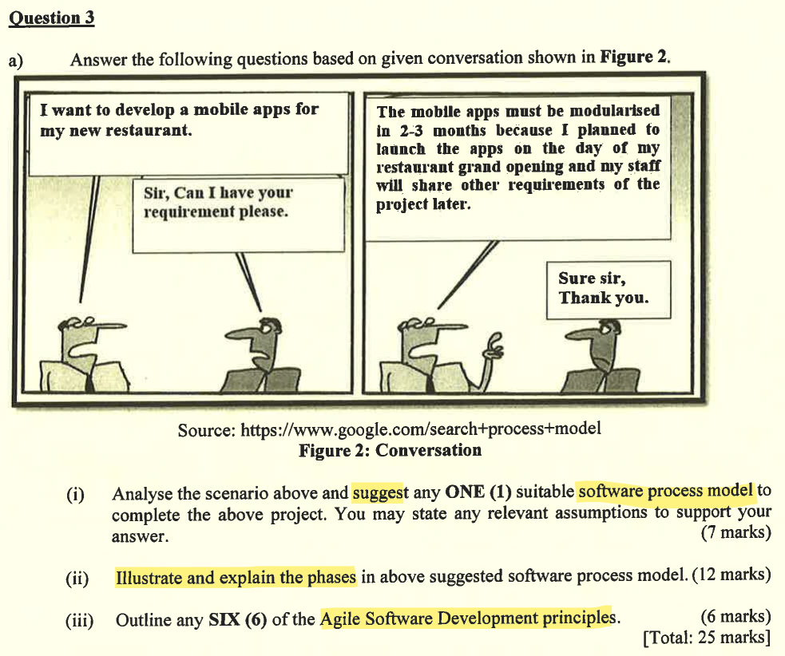
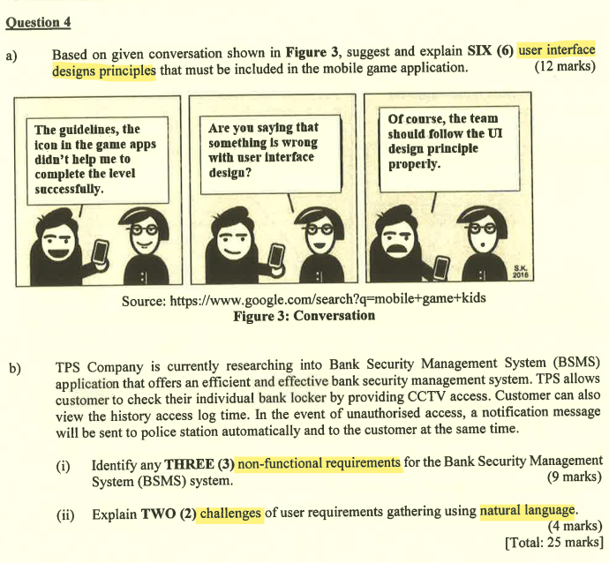

Tunku Abdul Rahman University of Management and Technology, Faculty of Computing and Information Technology (2024) BACS2163 Software Engineering (Academic Year 2023/2024, May/June Examination). Past Year Question Paper (Unpublished)
Tunku Abdul Rahman University of Management and Technology, Faculty of Computing and Information Technology (2024) BACS2163 Software Engineering (Academic Year 2023/2024, January Examination). Past Year Question Paper (Unpublished)

Tunku Abdul Rahman University of Management and Technology, Faculty of Computing and Information Technology (2023) BACS2163 Software Engineering (Academic Year 2023/2024, October Examination). Past Year Question Paper (Unpublished)
Tunku Abdul Rahman University of Management and Technology, Faculty of Computing and Information Technology (2023) BACS2163 Software Engineering (Academic Year 2022/2023, May/June Examination). Past Year Question Paper (Unpublished)
Tunku Abdul Rahman University of Management and Technology, Faculty of Computing and Information Technology (2023) BACS2163 Software Engineering (Academic Year 2022/2023, January Examination). Past Year Question Paper (Unpublished)

